Medine Sahin

Dr. Foley & Dr. Snyder

Mie First

1) How does the spectrum change as you increase the dielectric constant of the surrounding materials? Try n = 1.45 for glass and n = 1.76 for alumina.

1. Water

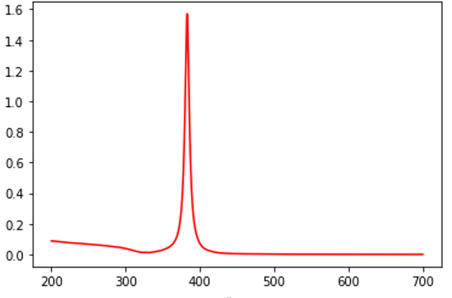

1. Glass

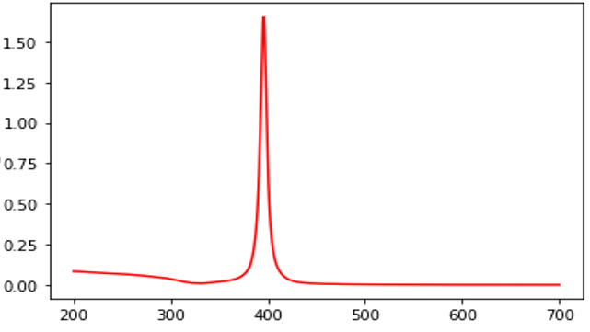

1. Alumina

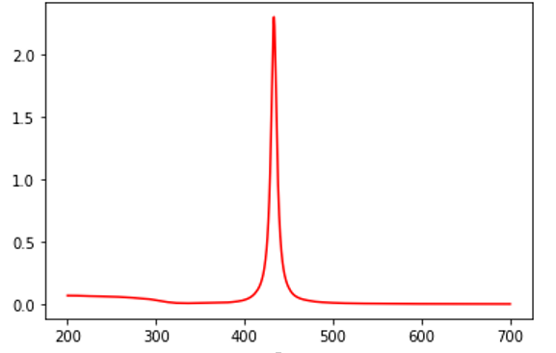

As we increase the dielectric constant of the surrounding materials (aka water, glass & alumina) we see a red shift in our wavelength, having red shift in wavelength usually means an increase on the wavelength. In our simulations, we get 1.33 for water, 1.45 for glass, and 1. 76 for alumina as a dielectric constant.

2) How does the spectrum change as you decrease the dielectric constant of the surrounding materials? Try n = 1.0 for air.

* As we expect it from our experience with the first question, we see a blue shift, decrease in our wavelength. As the dielectric constant, we get 1.33 for water and 1.0 for air.

1. Air

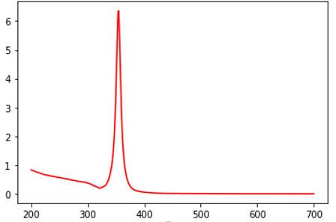

1. Water

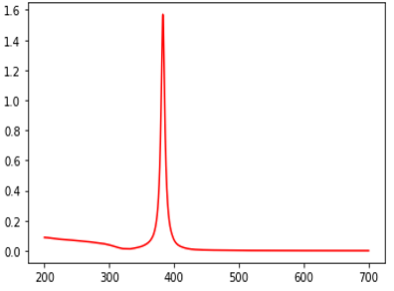

3) How does the spectrum change if you use Au instead of Ag?

1. Gold (Au)

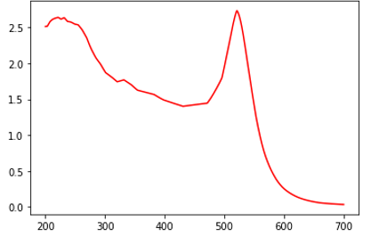

1. Silver (Ag)

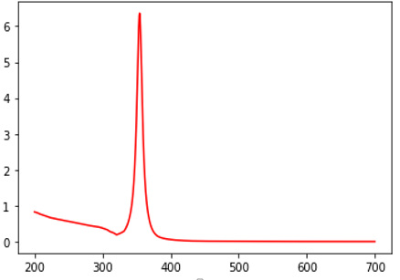

As seen in the figure above, if we were to use gold instead of silver, we will experience a red shift as we did in our first question.

4) Plot the real and imaginary parts of the dielectric function of Au and Ag as a function of wavelength; what do you notice about the values in the vicinity of the plasmon resonance (i.e. at wavelengths where the strong absorption peak is observed?

1. 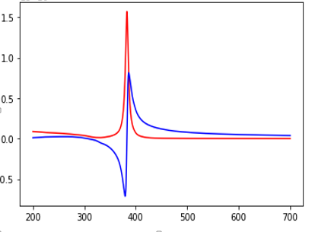

Blue spectra is denoted as the real part of the wavelength and the red spectra is imaginary part. As seen from the figure, the blue part of the wavelength has negative outcome comparing the wavelength of red (imaginary). In addition to this, the red spectra tends to have stronger absorption peak than the blue one due to having positive outcome in its spectra. As the vicinity increases the absorption decrease, they have an indirect relationship with each other, meaning that one vicinity increases the absorption decrease and when absorption increase the vicinity decreases.

1. 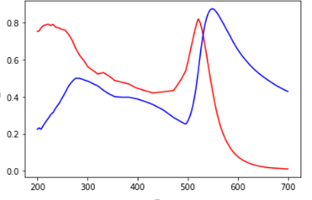

This spectra is has the real (blue) and imaginary (red) parts of the dielectric function of gold as a function of wavelength. Similar to the previous figure, we see an indirect relationship on the ride side of the spectra but as we focus on the left side we see a direct relationship where one increases the other one also increase and vice versa.